Hacker House Testing Plan Week 4

Test | Expected result | Obtained expected results | Evidence
Launch the game and test every main-menu button, player-name entry and difficulty selection. | All screens open in the same window. Blank names become “Player,” and Easy, Normal and Hard start correctly. | Yes | 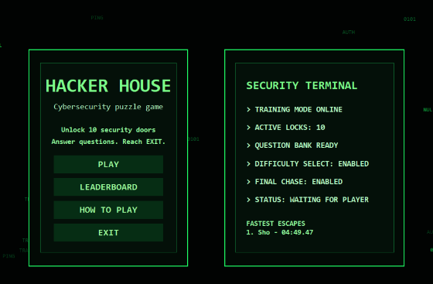  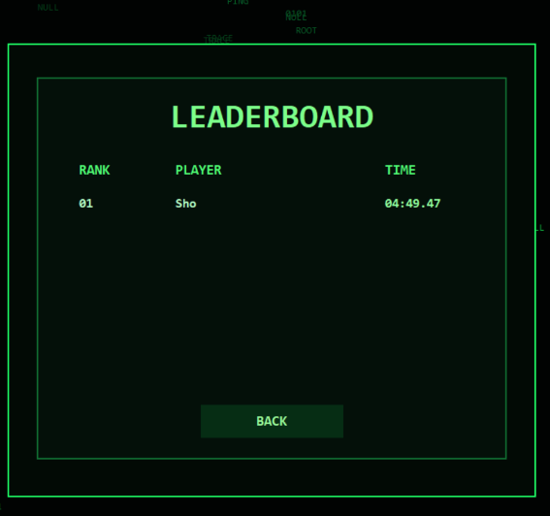  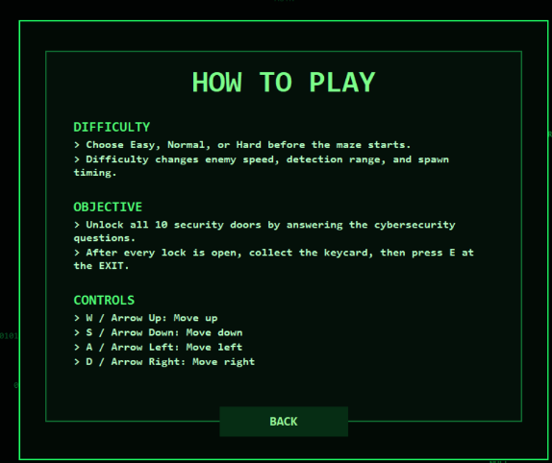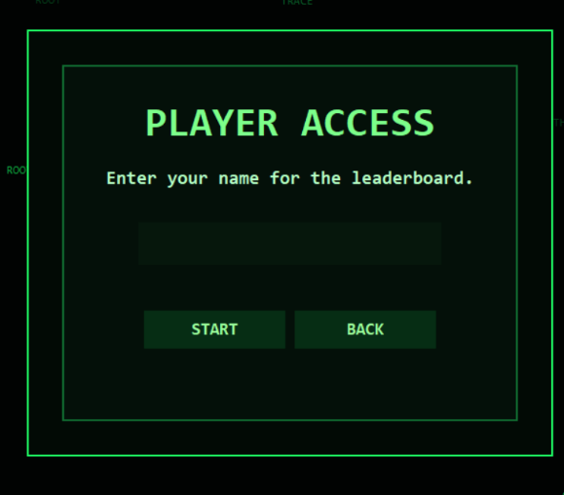
Test movement using WASD and arrow keys. Attempt to walk through walls, locked doors and outside the map. | Movement and facing work correctly, while blocked areas remain inaccessible. | Yes
Face a door and press E. Test the hacking animation, quiz, hints, Submit, Enter and Cancel controls. | The hacking animation finishes before the quiz opens. The quiz can be submitted or cancelled without errors. | Yes | 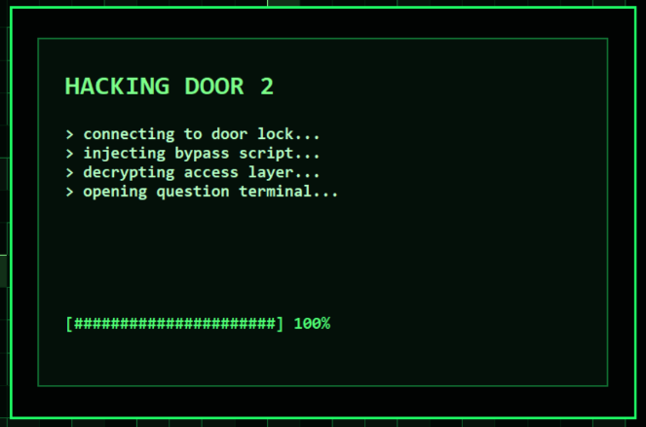  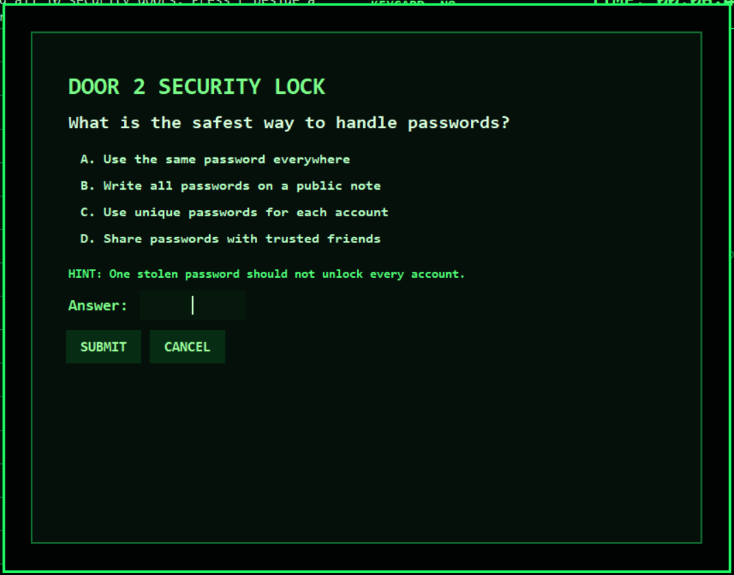
Submit correct, incorrect and blank answers. Retry an incorrect door immediately and after five seconds. | Correct answers unlock doors. Wrong or blank answers remove one life, trigger feedback and prevent another attempt until the cooldown ends. | Yes | 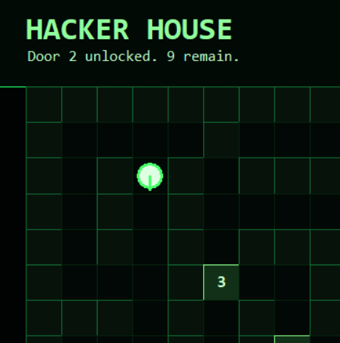
Pause during gameplay, hacking and a quiz. Test Resume, Restart Level, Main Menu and confirmation prompts. | Timers, cooldowns, animations and enemy movement freeze. Resuming restores the correct screen and any typed quiz answer. | Yes | 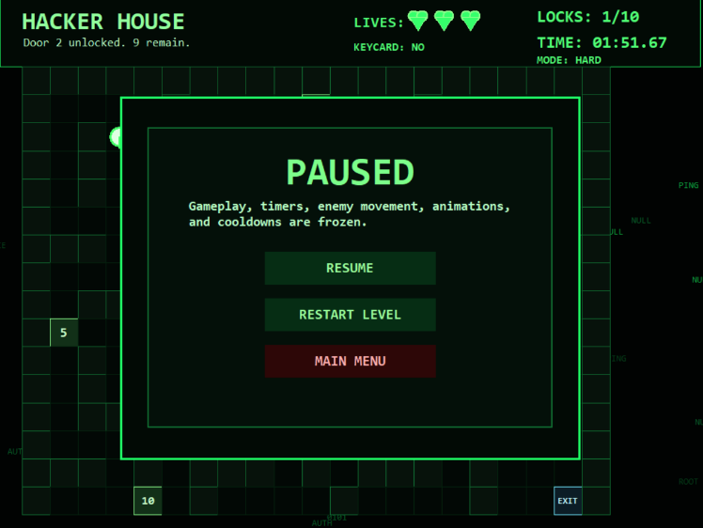
Test the enemy on every difficulty. Observe spawning, patrolling, detection, chasing, investigating doors and searching. | The enemy spawns after 5, 3 or 2 unlocked doors depending on difficulty. It moves continuously, detects nearby players and does not remain stuck after reaching a target. | Yes | 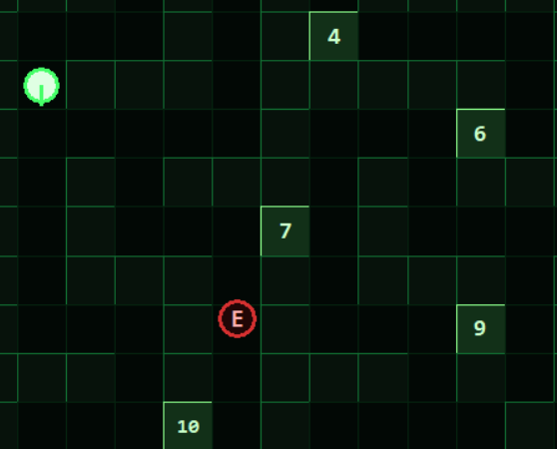
Allow the enemy to touch the player and separately lose all three lives through wrong answers. | The capture sequence begins, controls are disabled and the captured screen displays Restart and Main Menu options. | Yes | 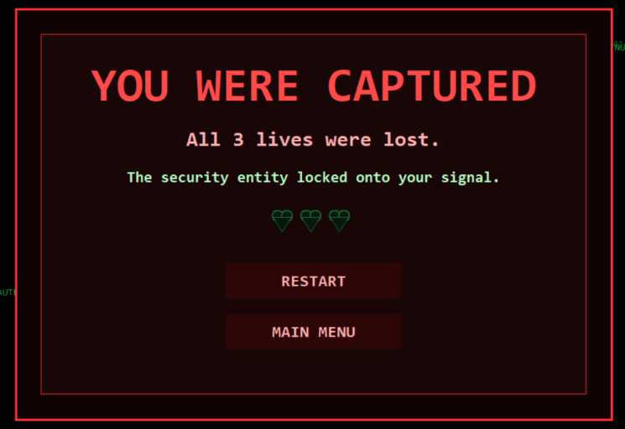
Unlock all 10 doors, collect the spawned keycard and attempt to use the exit before and after collecting it. | A reachable keycard appears, the final chase begins and the exit only works after the keycard is collected and E is pressed while facing it. | Yes | 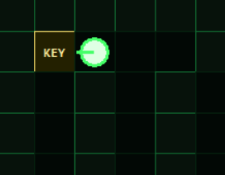
Resize the window, toggle fullscreen with F11 and inspect the HUD on each screen. | Text and controls remain readable without overlapping. Lives, time, locks, difficulty, keycard, cooldown and enemy mode display correctly. | Yes
Test action sounds, the capture warning loop, restarting, returning to the menu and closing the game. | Sounds play at the correct time, fallback audio works when needed and looping sounds stop when leaving or closing the game. | Yes
What went well?
Overall, I am happy with how the game turned. Major features/gameplay work as intended. The game also took huge inspiration from Pac-man (maze aspects) and Matrix (theme and aesthetics). The gameplay is also smooth and I believe that it achieves its goal of educating and spreading awareness about cybersecurity concepts.
What didn’t went well?
The enemy AI had a lot of issues and I couldn’t exactly pinpoint what was the issue. After fixing it, sometimes when the enemy catches the player it freezes the game but the timer still keeps going. There was also a lot of issues with the map creation as at times there were either no exit, missing some doors or having some other issues. The UI was also a bit annoying to fix as I kept experiencing overlap of texts with the interface.
.

